iPad Plan — My Cocktail Collection
Nov 12, 2026 · @Bill
Make the app feel native on iPad, using the larger screen, keyboard and trackpad, while the iPhone layout stays exactly as it is.

Where things stand
The app already installs on iPad: the project targets iPhone and iPad (device family 1,2), and iPad allows every orientation. But every screen uses the phone layout stretched to the larger screen: bottom tabs, one screen at a time, full-screen sheets, and lines of text that run the full width.
The goal is a layout that adapts to the space available. A full-screen iPad gets sidebars, columns and keyboard support. An iPhone, or an iPad app in a narrow Split View window, keeps today's layout unchanged.

Layout: sidebar and side-by-side columns
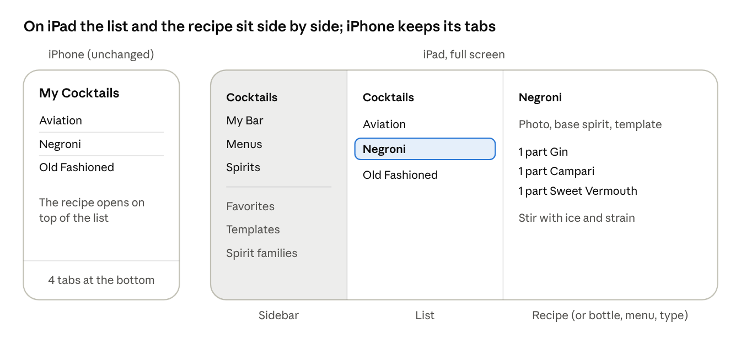
iPhone vs iPad layout · sidebar, list, detail
On a full-screen iPad, the bottom tabs become a sidebar, and each section shows its list and the selected item side by side, so nothing is pushed on top of anything else.
- Sidebar: Cocktails, My Bar, Menus and Spirits, plus one-tap shortcuts for Favorites, the six templates and the spirit families. These replace opening the "…" filter menus.
- List and detail: tap a cocktail and its recipe fills the right-hand column. The same applies to a bottle in My Bar, a menu and its cocktails, and a type in Spirits. Arrow keys move the selection.
- The layout follows the width, not the device. An iPhone, or an iPad app in a narrow Split View or Slide Over window, gets today's tabs and push navigation automatically.

Readability on a big screen
Stretched across 11 or 13 inches, today's single column has very long lines and lots of empty space. On wide screens:
- Recipe screen in two columns: photo and details (base spirit, template, source) on the left; ingredients and How to Make on the right, so a whole recipe fits on one screen while you're mixing.
- Forms as centered panels: Add/Edit Cocktail, Add Bottle and New Menu open as a centered sheet with a comfortable width, not a full-screen stretch.
- Quick add in two panes: the ingredient list on the left and the ingredients you've added on the right, so you can see the recipe build as you tap.
- My Bar and Spirits as grids of cards when there's room, falling back to the current list in narrow windows.
- Text keeps a readable line length and stays sized by Dynamic Type.

Keyboard and trackpad
With a Magic Keyboard or a trackpad attached, the app should work without reaching for the screen.
Shortcut | Action
⌘N | New item in the current section (cocktail, bottle or menu)
⌘F | Search the current list
⌘E | Edit the selected item
⌘S | Save the open form
Esc | Cancel the open form
⌘⌫ | Delete the selected item (with confirmation)
↑ / ↓ | Move through the list
- Quick add from the keyboard: type to search, arrow keys to move, Return to pick, then type the amount. Tab accepts the name suggestion in the ingredient editor.
- Right-click and long-press menus on rows: Favorite, Edit, Add to Menu, Share, Delete.
- Hover highlights on rows and buttons when using a pointer.
- Holding ⌘ shows the list of shortcuts, which iPadOS does automatically once they're declared.

Later extras
Nice to have, not needed for a good iPad experience:
- Drag and drop: drag cocktails from the list onto a menu; drag a photo from Safari or Photos onto a recipe.
- Split View with Safari: read a recipe online on one side and enter it on the other, with Add from Text to paste a block of ingredients.
- Mac for free: the iPad build can also run on an Apple Silicon Mac, so the same layout work pays off there.

Steps
Step | What it covers | Size
1 | Sidebar and list–detail columns for Cocktails, My Bar, Menus and Spirits | Largest
2 | Wider layouts: two-column recipe, form panels, two-pane quick add, grids | Medium
3 | Keyboard shortcuts, context menus and hover | Small
4 | Drag and drop (optional) | Small
Each step stands on its own and can be committed separately. The iPhone layout stays as it is, and each step comes with iPad previews and UI tests run on an iPad simulator.

Decisions
- Minimum iOS version. Raising it from 17.2 to 18 lets the app use the built-in tab bar that turns into a sidebar on iPad, and better sheet sizing, with much less code. Staying on 17 means building the sidebar by hand with a split view, which works but is more to maintain. Recommendation: move to iOS 18 if both of your devices run it.
- Which iPad and iOS version you have, so the layouts are tested at the right size.
- Whether the sidebar shortcuts (Favorites, templates, spirit families) belong in step 1 or later.

